**3. Materials and Methods**

**3.1. Species and site selection with sampling periods**

*Ompok bimaculatus* (pabda) is a commercially significant fish that is well-known for its flavor among the local community. There has been no investigation into the consumption of microplastic by this species of fish in the Kaptai Lake. In order to learn more about this aspect, the current work was done.

Three sampling stations: St-1 (Banarupa Bazar), St-2 (Reserve Bazar), St-3 (Tabalchori Bazar) were selected based on their location and fish availability. These stations are located at Rangamati district in Chattogram, Bangladesh. Newly harvested fish were easily purchased for this research. The sampling period was from November 2022 – January 2023.

Table 3.1. Latitude and Longitude of the three sampling stations

|  |  |  |  |
| --- | --- | --- | --- |
| Sampling station | Sampling code | Latitude (°) | Longitude (°) |
| Banarupa Bazar | S-1 | 22.6533463 | 92.178975 |
| Reserve Bazar | S-2 | 22.6524216 | 92.196527 |
| Tabalchari Bazar | S-3 | 22.6389663 | 92.186583 |

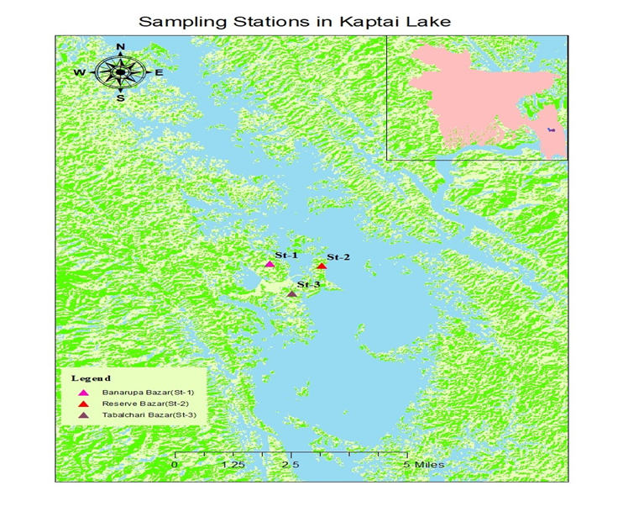

**Figure: Location of the sampling stations.**

**3.2. Selection of methods**

Most polymers can be badly damaged or destroyed by acids like HCl, formic acid, and HNO3 (Lusher et al., 2017). Acids like these can eliminate biological components. Strong bases, such as KOH and NaOH, are also useful for breaking down crustaceans and fish fillets, but they are unsuitable for use with actual fish (Horton et al., 2017). H2O2 is chosen because it is an effective digestant, in accordance with earlier investigations (Avio et al., 2015). NaCl is chosen because it is cheap, easily accessible, and non-hazardous for density separation. However, employing NaCl may result in an underestimate of denser particles (1.2 gcm-3).

**3.3. Sample collection**

Fresh *Ompok bimaculatus* from Kaptai Lake was obtained for this study between November 2022 and January 2023 from three separate marketplaces on the lake's shore. A total of 40 *Ompok bimaculatus* individuals were gathered, with 15, 15, 10 individuals obtained from St-1: Banarupa Bazar, St-2: Reserve Bazar, and St- 3: Tabalchari Bazar, respectively. Following that, samples were brought to the lab for storage and stored in an icebox to preserve and transport them. All samples were frozen at -20°C, thawed in room temperature for 30 minutes, and washed with distilled water. To guarantee a clean working environment free of plastic contamination, all laboratory surfaces and equipment were washed with 100% ethanol and then visually examined for the presence of plastic pieces. Total length (TL), a straight-line measure (not measured over the curve of the body) from the tip of the snout to the longest lobe of the caudal fin (cm), standard length (SL), a straight-line measure from the tip of the snout to the posterior end of the last vertebra, body weight (g), girth (maximum length between the ventral and dorsal sides; cm), and general body condition, as determined by the presence of physical injury and parasites were recorded (Cannon et al., 2016) The length and weight of the fish samples were measured using a centimeter scale and an electronic balance (AND-GULF, model: EK600).

**3.4. Sample dissection**

The specimens were dissected separately in a metal tray using scissors, scalpels, and forceps. Firstly, the gastrointestinal tract (GIT) was removed by cutting through the esophagus, keeping the whole stomach intact. Next, the gut should be cut some millimeters before the anus to avoid contamination through the anus (Hermsen et al., 2017), transferred to a Petri dish, weighed, and again transferred to a glass beaker.

**3.5. Sample processing and analysis**

**3.5.1. Digestion of fish GIT (gastrointestinal tract)**

Approximately 30 ml of 30% H2O2 was added to each beaker to digest the organic matter depending on the soft tissue weight in each beaker. The volume of liquid did not exceed 50% of the total volume of the beaker (Li et al., 2015; Su et al; 2016) Then a stir bar was added to the beaker and covered with aluminum foils. The beaker was placed in an incubator at 65°C for 48-72 hours for whole digestion of the tissue. Then beaker was kept at room temperature (25°C) for 24-48 hours depending on the digestion effect of the soft tissue to obtain a dissolved solution (Avio et al., 2015)

**3.5.2. NaCl solution floatation and filtration**

A saturated sodium chloride (NaCl) solution was prepared and filtered. Approximately 30 ml of filtered NaCl solution was added to each beaker to separate plastics from the dissolved solution of the GIT via floatation. The solution was mixed by stirnng and kept overnight at room temperature to observe the clearance level (Jabeen et al., 2017). The next day all fats and organic matters were in the bottom and a 1-2 cm layer of plastic floated upwards. Then the supernatant was pipetted by a micropipette and placed in a clean beaker. Then they were sieved (Hermsen et al., 2017) through a 53 µm stainless steel sieve (ASTM test sieve). The residue on the sieve was backwashed into a clean Petri dish with filtered distilled water and covered for further analysis.

**3.5.3. Microscopic observation and identification**

The samples were visually inspected under a microscope (Zenith IAb Biological Microscope, XSZ- 107BN) at 4X objective magnification (eyepiece: 10X), and pictures of microplastics were taken with a microscope eyepiece camera (AmScope, microscope eyepiece camera, model no: MD500). Microplastics were identified visually following Marine Environmental Research Institute (MERI) guidelines (Hidalgo-Ruz et al., 2012). Classification according to types was done by categorizing MPs in fibers, thread- line and fragments (Galgani et al., 2015). Microplastics were also classified into four colors (red, black, blue and transparent). In addition, all microplastics were measured at their largest cross-section and categorized according to the following size classes 150-1000 µm, 1000-2000 µm, 2000-3500 µm, and 3500-5000 µm. Each particle’s longest or widest dimensions were measured to the nearest micrometers (Choy and Drazen, 2013; Phillips and Bonner, 2015)

3.5.4. Data analysis

Data were analyzed using Microsoft Excel spreadsheet software and R statistical software with different analytical tests.

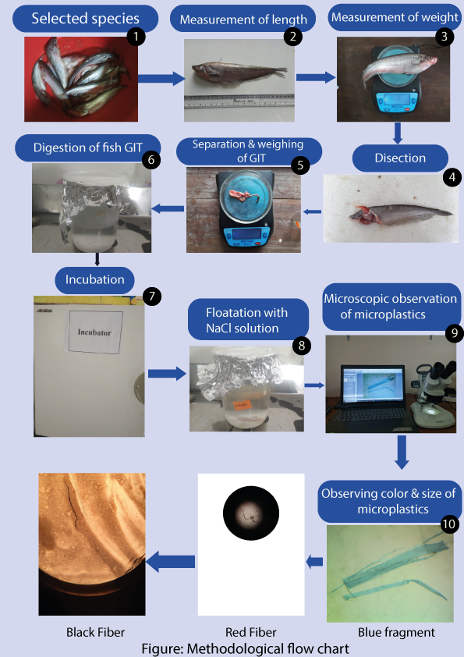

**3.6. Quality control of experiments**

As contamination with airborne fibers is a recurring phenomenon in microplastic research (Davison and Asch 2011; Foekema et al., 2013), it was important to ensure a steriale working environment. Care was taken during fish sample collection, transportation, preservation, thawing, washing, dissection, and removal of the gastrointestinal tract (GIT), alkali digestion, NaCl floatation, and microplastic identification (Hossain et al., 2019). All laboratory surfaces and equipment were cleaned using 100% ethanol and then usually inspected tor the presence of plastic fragments. All apparatus (e.g., glass wares dissection tools) were rinsed three times with filtered distilled water to reduce the chances of contamination (Li et al., 2015; Lusher et al., 2015; Yang et al., 2015). Distilled water. saline water, and hydrogen peroxide were filtered with I l gm filter papers (Whatman qualitative filter papers, grade-I, cat no 1001-1 10, diameter: 110 mm) prior to use. Exclusive cotton laboratory coats, bouffant caps, glasses, and latex gloves were worn during the experiments (Hossain et al., 2019; Jabeen et al., 2017; Neves et al., 2015). Dissection of the specimen and removal of the gastrointestinal tract (GIT) was done swiftly. and the GTS placed in a Petri dish were immediately covered (Devriese et al., 2015; DeWitte et al., 2014). When not in use, the samples were immediately covered with roil (Hossain et al., 2019). The experimental procedures without fish tissues for each species were performed as blank experiments (Jabeen et al., 2016, Li et al., 2015).